- Create VPC with 2 private and 2 public subnets.
Create a vpc VPC → Create VPC
Click Create VPC
Create 2 Public Subnets and private subnets
public-rt → Subnet associations → Edit subnet associations
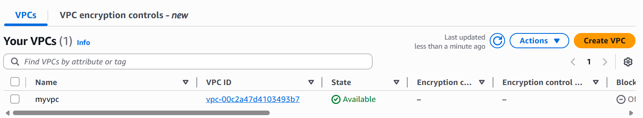
2 pubic subnets
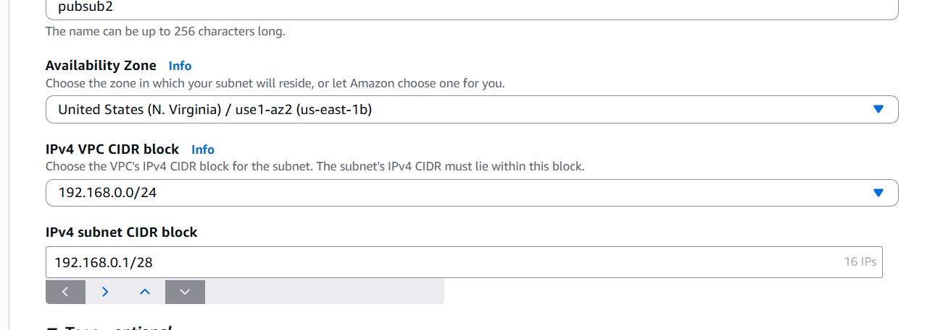
Private key setups
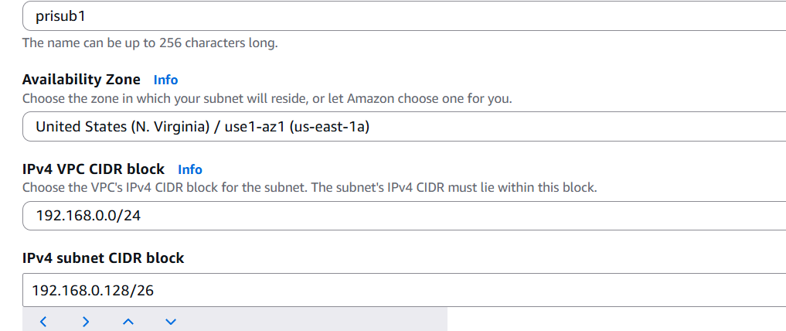

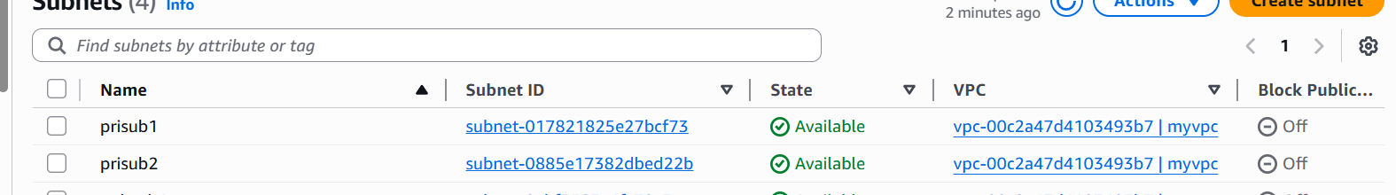

- Enable DNS Hostname in VPC.
Actions → Edit VPC settings
Enable DNS hostnames → TURN THIS ON
Save enable

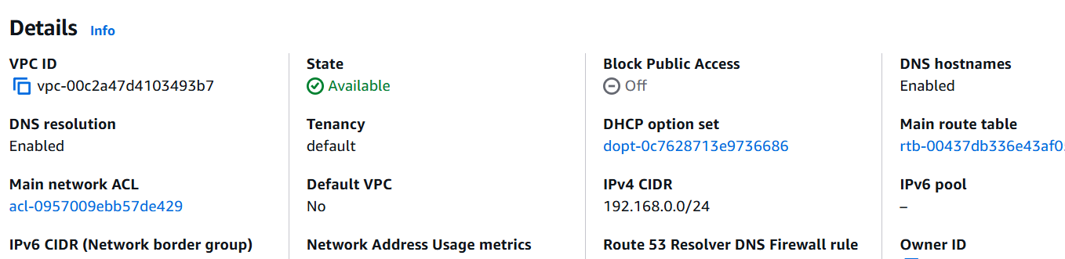

- Enable Auto Assign Public IP in 2 public subnets.
Go to VPC Console
Left side → Subnets
Click public-subnet-1
Click Actions
Select Edit subnet settings
Enable: Auto-assign IPv4 public IP

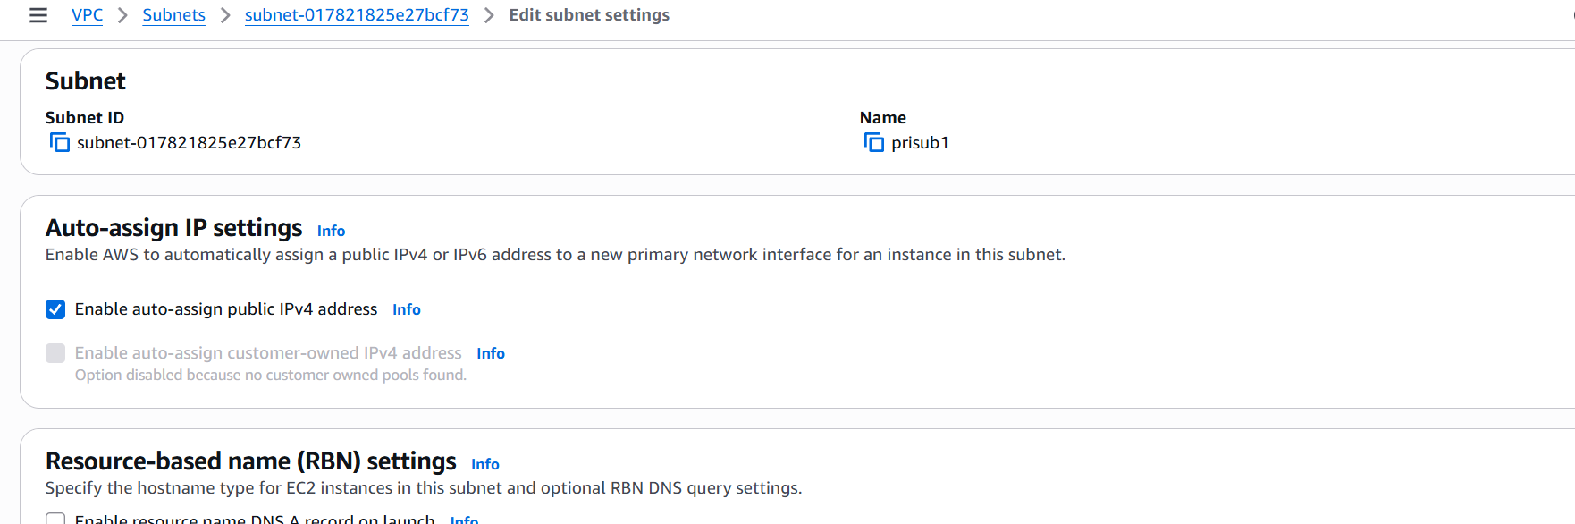
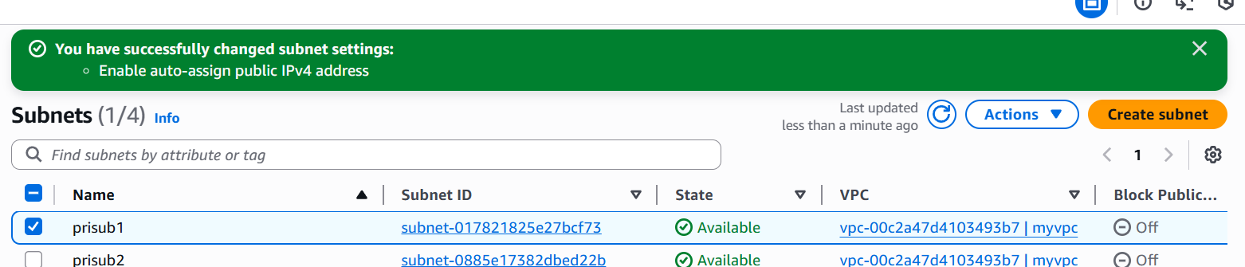

- Add 2 private subnets in private route table.
Click the Subnet Associations tab
Click Edit Subnet Associations
You will see a list of subnets → tick the two public ones:
✔ public-subnet-1
✔ public-subnet-2
Click Save Associations

- Add 2 public subnets in public route table.
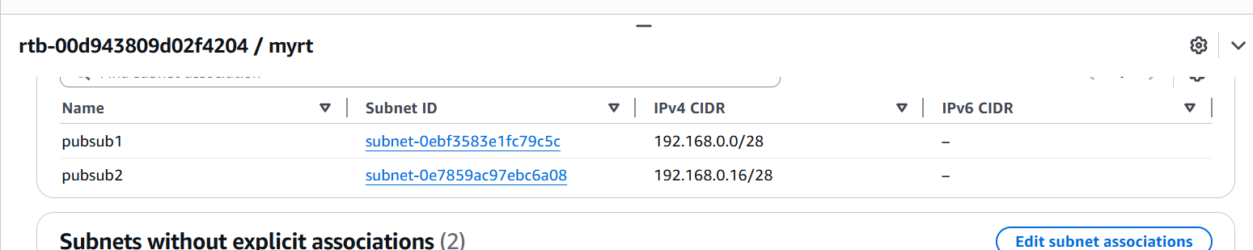

- Public route table will have the routes to internet and local.
• Left → Route Tables
• Select public-rt
Click the Routes tab
➡ This is created automatically by AWS
➡ It allows all subnets in the VPC to communicate internally
You do not need to add this manually.
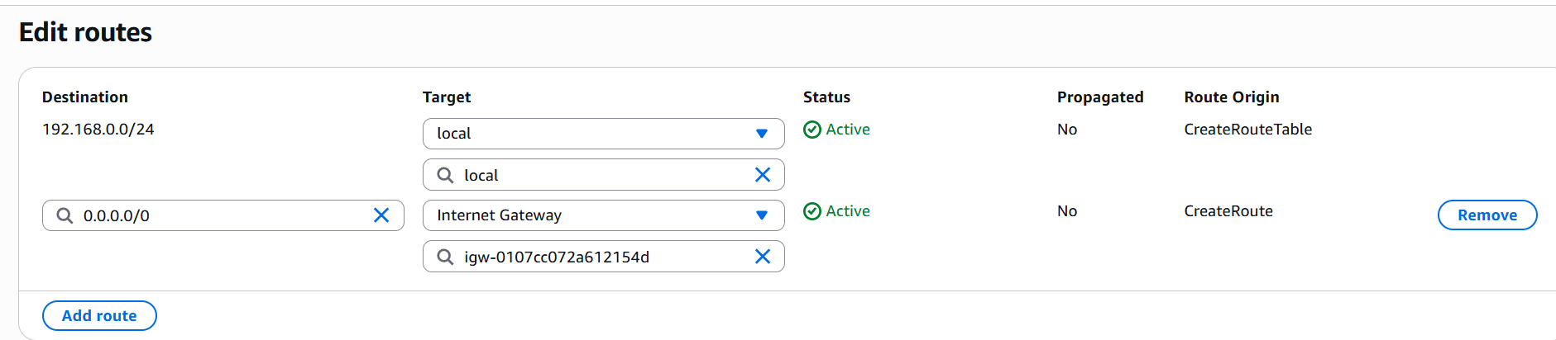
- Create EC2 in public subnet with t2.micro and install PHP.
1. Launch EC2
- AMI: Amazon Linux 2
- Instance: t2.micro
- Subnet: Public subnet
- Auto-assign Public IP: Enable
- Security group:
  - SSH → 22 → My IP
  - HTTP → 80 → 0.0.0.0/0
- Launch
2. Connect to EC2
ssh -i key.pem ec2-user@PUBLIC-IP
3. Install PHP + Apache
sudo yum update -y
sudo amazon-linux-extras enable php8.0
sudo yum install -y httpd php
sudo systemctl start httpd
sudo systemctl enable httpd
(or)
user data : #!/bin/bash
yum update -y
yum install -y httpd php
systemctl start httpd
systemctl enable httpd
echo "<?php phpinfo(); ?>" > /var/www/html/index.php
Launch Instance

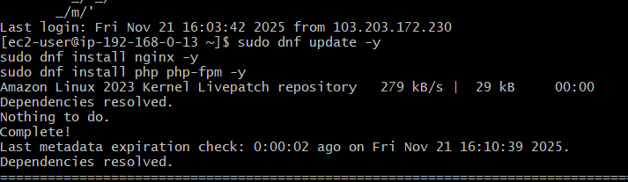
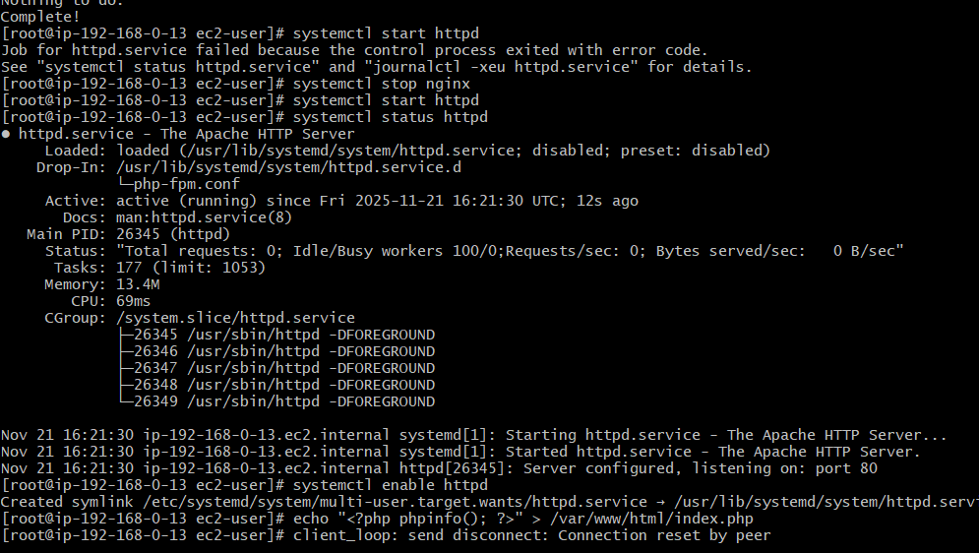
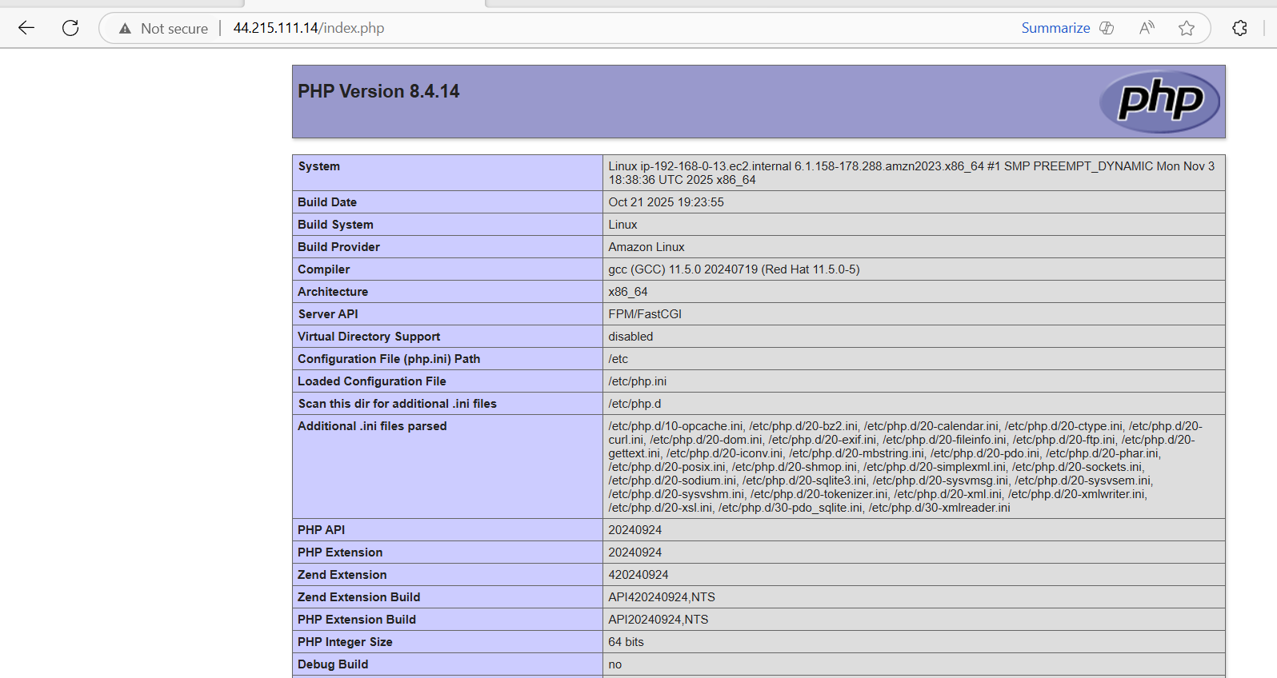
- Configure NAT gateway in public subnet and connect to private instance.
Go to Elastic IPs ◊ Allocate Elastic IP
Go to NAT Gateway ◊ Create NAT Gateway
Name : my-nat
Subnet : public-subnet-01
Elastic IP : Select allocated
Create
Update Private Route Table
Route Tables ◊ private-RT
Routes
Edit routes
Add : Destination : 0.0.0.0/0
Target : NAT Gateway
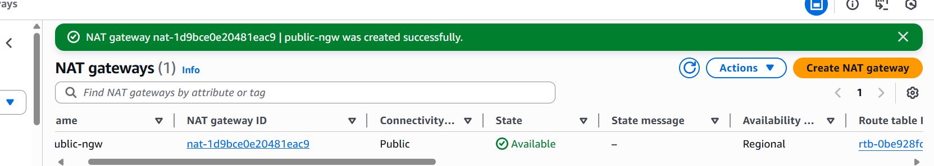
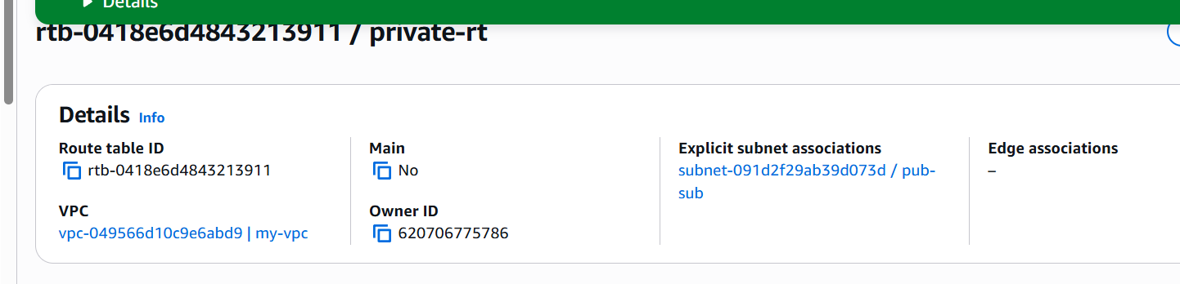
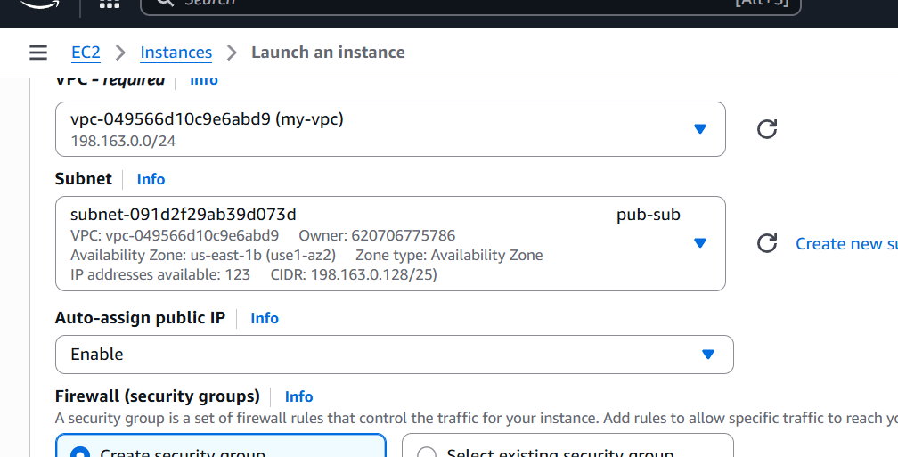

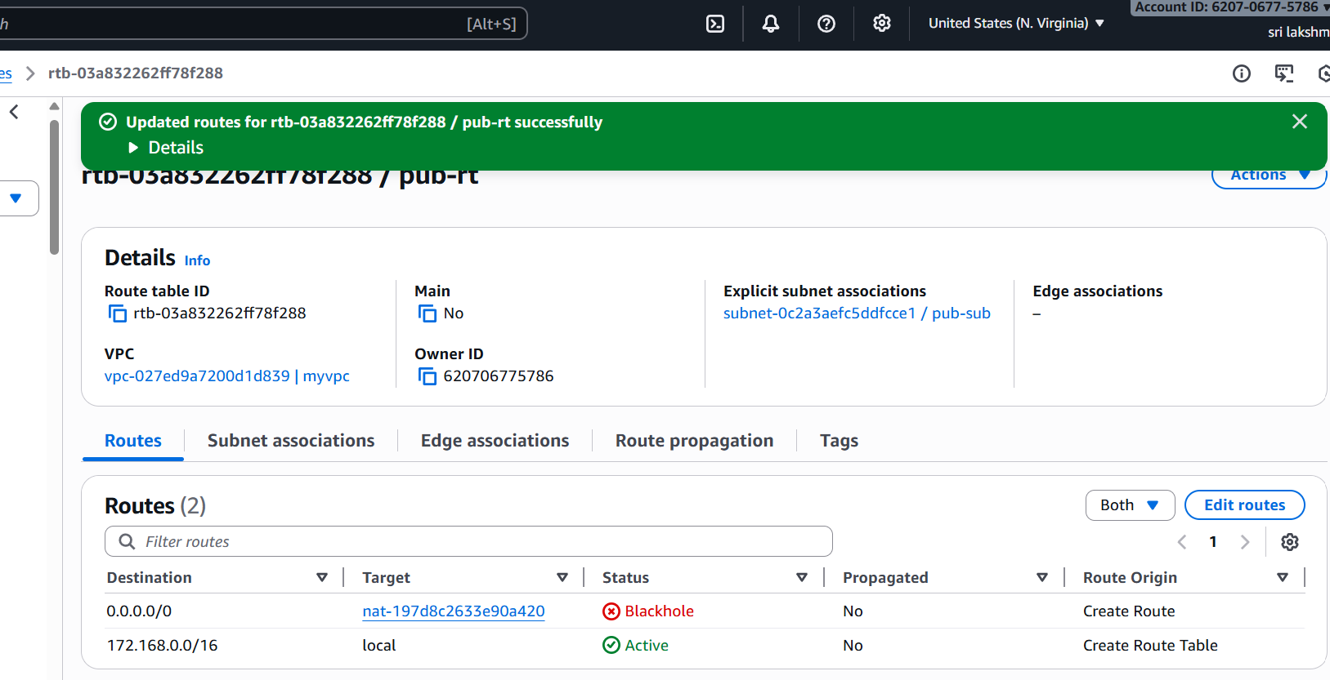
Now private servers can access the internet
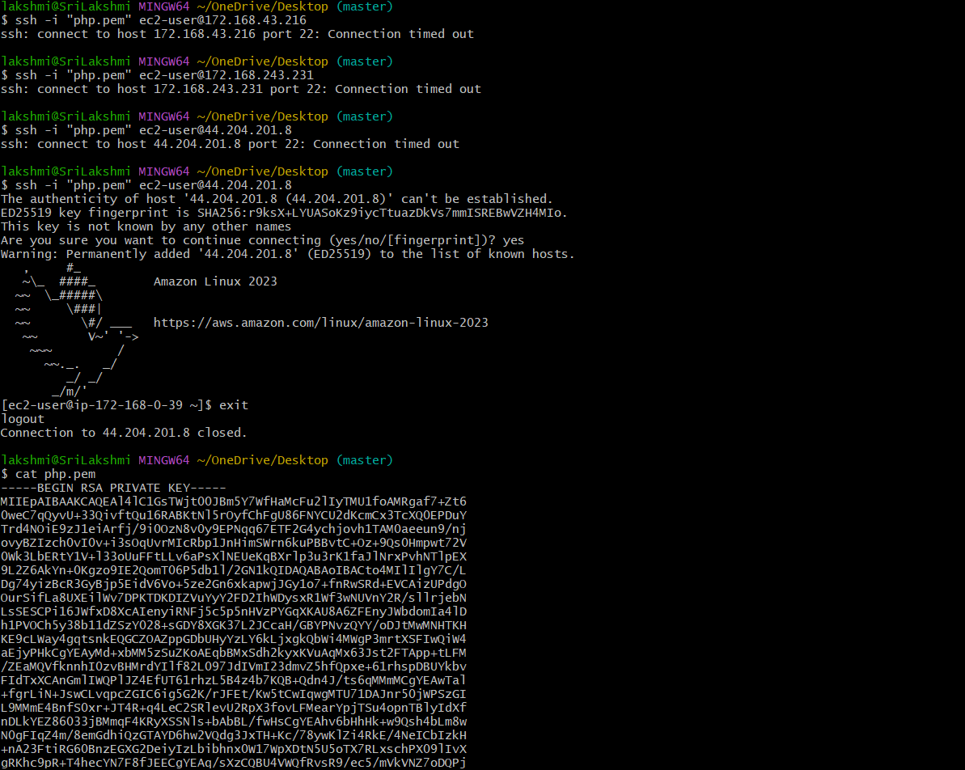
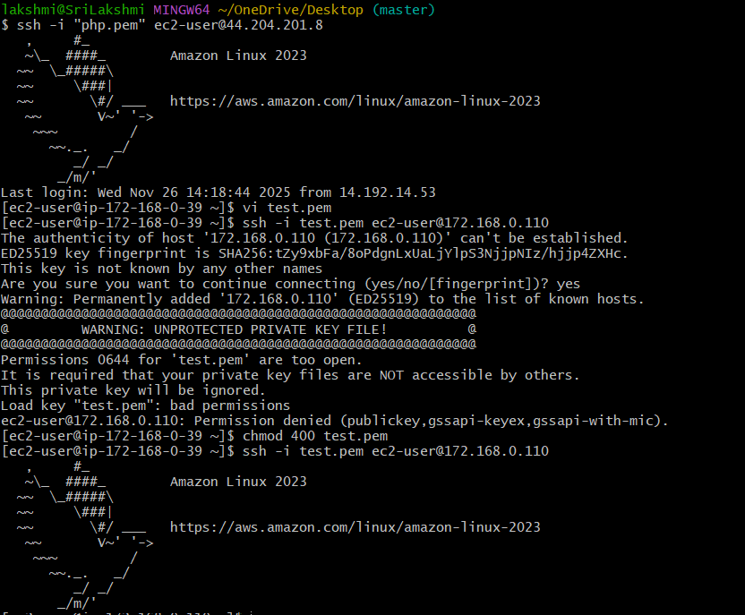
- Install Apache Tomcat in private EC2 and deploy a sample app.
Launch Private ec2 (Tomcat Server)
Ec2 Launch instance
Name : private-tomcat
AMI : Amacon Linux 2
Instance type : t2.micro
Key pair : avengers.pem (select exixting)
VPC : my-vpc-01
Subnet : public-subnet-01
Auto Assign Public IP : Disabled
Security Group : SSH only from internal VPC (10.0.0.0/16)
Tomcat Port (8080) allow internal network only
SSH into Private ec2 via Public ec2
From laptop
ssh into public server : ssh -I “avengers.pem” ec2-user@<public-ip>
then the public to privte :ssh -I (keyname) ec2 @user(ip)
install java and tomcat on private ec2
sudo yum update -y
yum install java -y
install tomcat
systemctl enable tomcat
deploy sample web app in tomcat cd/tem
cd /opt
wget(link)
tar .xvf apache tomcat
cd apache tomcat
cd webapps
wget(sampl war link)
cd ..
cd bin
./startup.sh
Start tomcat
Curl http://localhost”:8080/sample

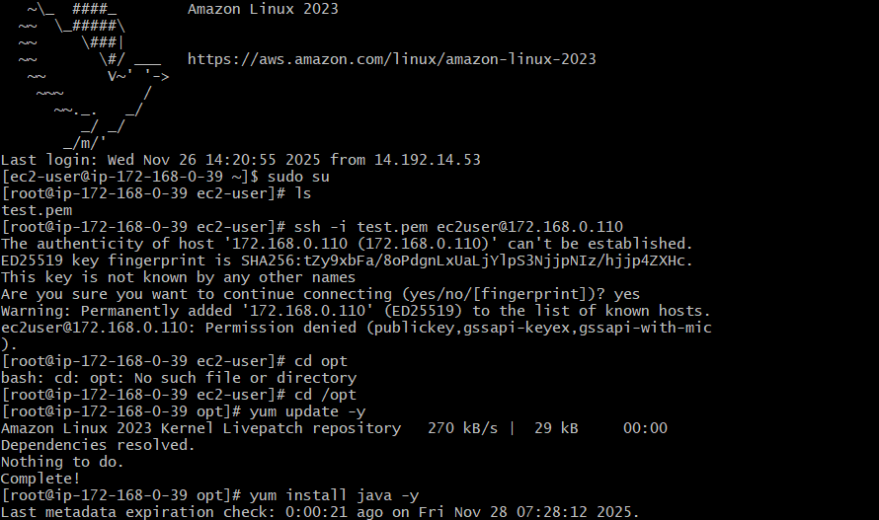
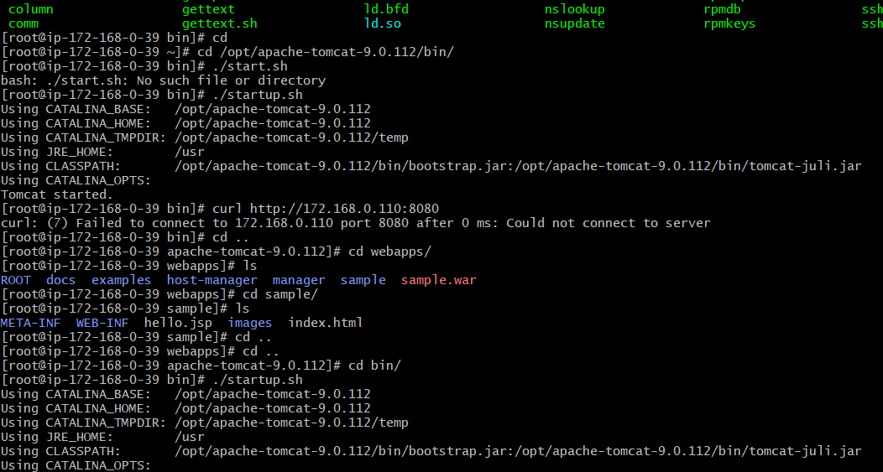
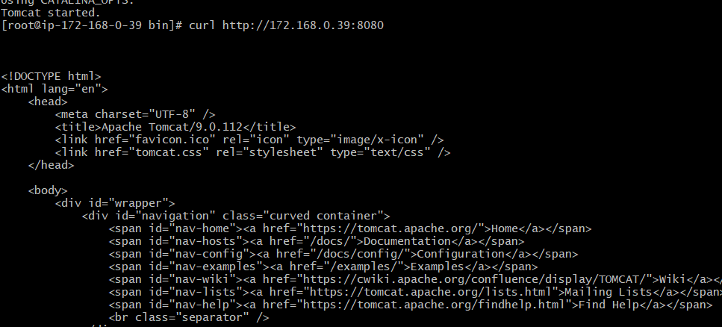
- Configure VPC flow logs and store the logs in S3 and CloudWatch.
Before creating the flow log, CloudWatch needs a log group.
Open CloudWatch
• Go to AWS Console
• Search CloudWatch
• Select CloudWatch
Create Log Group
1. In left menu → choose Logs → Log groups
2. Click Create log group
3. Enter:
Log group name: vpc-flow-logs
4. Click Create
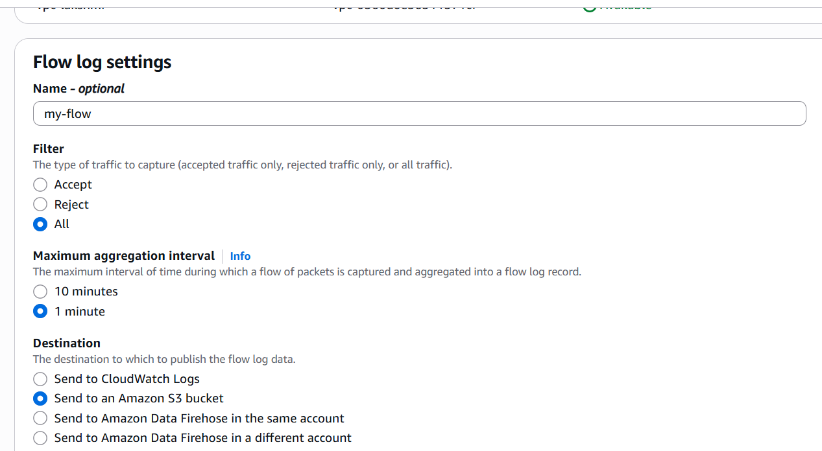
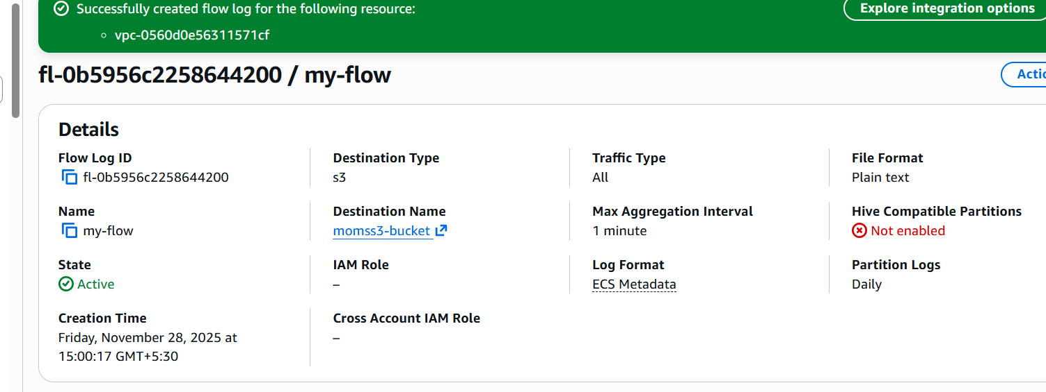
Create S3 Bucket for Flow Logs
Now create an S3 bucket to store raw flow log files.
Open S3
• Go to AWS console → S3 service
Create bucket
1. Click Create bucket
2. Enter:
Bucket name: vpc-flowlog-bucket-shahbazz
3. Region: Same region as your VPC
4. Keep all default settings
5. Click Create bucket
3. Create VPC Flow Logs (CloudWatch Destination)
Go to VPC Dashboard
• AWS Console → VPC
Select Your VPC
1. From left menu click Your VPCs
